**SWINBURNE UNIVERSITY OF TECHNOLOGY**

**COS30045**

**ASSIGNMENT 1**

**COST OF LIVING**

|  |  |  |
| --- | --- | --- |
| **NAME & STUDENT ID** | **:** | **Nguyen Gia Binh (104219428)** |
|  |  |  |
| **CLASS** | **:** | **COS30045** |
| **LECTURER**  **TUTOR** | **:**  **:** | **HOANG XUAN TUNG**  **(**txhoang@swin.edu.au**)**  **HOANG XUAN TUNG**  **(**txhoang@swin.edu.au**)** |

**Hanoi, February 17, 2024**

**TABLE OF CONTENTS**

TABLE OF CONTENTS

**CHAPTER 1: INTRODUCTION**

1.1. Rationale

1.2. Background information

1.3. Aims and objectives

**CHAPTER 2: METHODOLOGY**

**CHAPTER 3: VISUALIZATION REVIEW**

3.1. Visualization 1

3.2. Visualization 2

3.3. Visualization 3

**CHAPTER 4: DISCUSSION**

**CHAPTER 5: CONCLUSION**

**REFERENCES**

**CHAPTER 1: INTRODUCTION**

**1.1: Rationale**

In our modern and mobile-centric society, it is crucial for numerous individuals, businesses, and policymakers to grasp the complexities of living expenses in different places. The ability to make informed choices regarding residence, employment, or investments relies heavily on obtaining and understanding precise information about the economic variations in various regions. Data visualization have become effective instruments for presenting this frequently intricate information in a comprehensible and compelling manner. But because data and designs are tricky, even good visualization might have mistakes and make us understand matters the wrong way. The key aim of this paper is to analyze chosen existing visualization to have a deeper understanding of their strengths and weaknesses.

**1.2: Background information**

Data visualization is more than just visual representation, it is a powerful methodology for transforming complex datasets into comprehensible narratives and facilitating the extraction of deeper insights. To make the most of this method, it is crucial to have a comprehensive grasp of its fundamental principles and concepts:

**-** Data Types: It describes the different categories of data such as:

* Quantitative: Uses numbers to depict precise values, the number can flows seamlessly, taking on any value within a specific range or jumps in distinct steps, taking on specific values within a set.
* Qualitative: revealing the distinct characteristics and distributions within a dataset:

1. Nominal data: Labels with no inherent order, country of origin or blood types.
2. Ordinal data: Labels with a meaningful order, like customer satisfaction ratings or clouth size.

* Temporal: revealing information across the stage of time, showcasing patterns and progressions

**-** Types of visualization: Data can be visualize using charts, graphs, maps and diagrams. Each type serves a specific purpose and is chosen depending on the data's characteristics and the matters you want to convey.

**-** Data visual encoding: This is the mapping of data attributes to visual elements like color, size, shape, and position within a visualization.

**-** Effectiveness and Expressiveness: Effective visualizations are clear and to the point, but they should also go beyond surface-level observations to reveal deeper patterns.

**-** Design principles: it guides the visualization that not only present the data accurately but also ensure clarity

* Simplicity: Design for intuitive comprehension, avoiding convoluted explanations or cluttered presentations (Ware, 2019).
* Consistency: By avoiding unnecessary design surprises, you free up viewers' mental energy to focus on what really matters – the data itself (Munzner, T., 2014).
* Balance and Proportion: Visualizations should amplify the data's voice, not distort it. Achieving balance and proportion prevents any singular element from shouting over the others, ensuring the data speaks truthfully and avoids presenting a skewed narrative (Harris, 1999).
* Hierachy and Emphasis: Humans naturally gravitate towards what's visually prominent. Leverage this by using a hierarchy to create an intuitive visual experience. Guide the viewer's eyes to the important information effortlessly, using size, color, and positioning like visual cues that resonate instinctively (Few, 2012).
* Labeling: Fonts, sizes, and labels can also create a visual hierarchy within your visualization. Use them strategically to highlight key information, just like you might use bolding or italics in writing.
* Accessibility: Inclusive design expands your audience, diverse perspectives enrich interpretations, and impact soars

**1.3: Aims and objectives**

The overall aim of our research is to assess 3 separate chosen visualization from 2 or 3 research/study papers related to the cost of living. Each visualization will be analyze to identify best practices and fostering improvement.

**CHAPTER 2: METHODOLOGY**

According to the Data visual encoding, Effectiveness and Expressiveness and Design principles established above, each visualization will undergo undergoes a two-step analysis consisting of Initial Observation and Criteria-Based Evaluation. The first step which is initial observation will look at the overall design of the visualization. In the evaluation step we will be using the 3 criteria mentioned above to see the pros and cons of each visualization. This focused analysis helps us understand each visualization's strengths and weaknesses, ultimately fostering the creation of better data stories.

**CHAPTER 3**: **VISUALIZATION REVIEWS**

**3.1: Visualization 1**

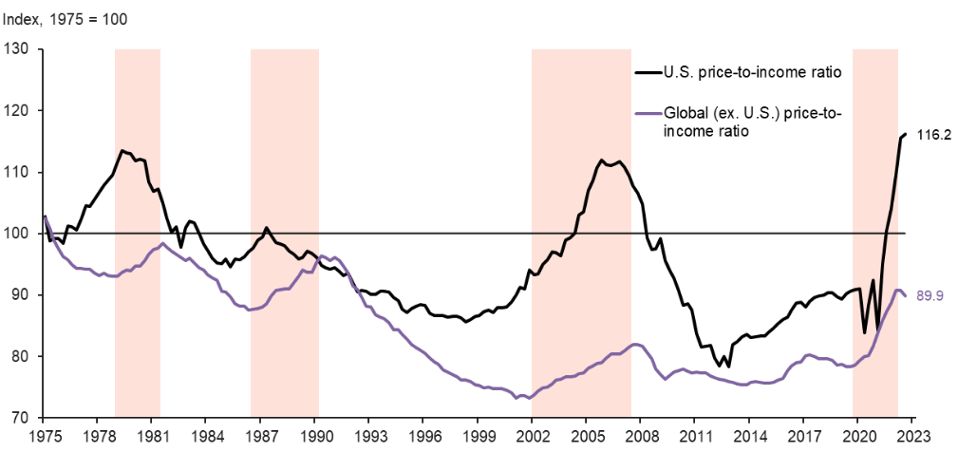

At first sight, The presentation is straightforward and easily comprehensible. The labels for the price-to-income ratios for both the United States and the global values are distinctly indicated, and the axes are appropriately labeled. The visualization lacks insights beyond highlighting the consistent trend of the US price-to-income ratio surpassing the global ratio since the 1970s. Nevertheless, it does illustrate a discernible pattern of both ratios steadily rising over the years.

With deeper analysis, I can say that The visualization is relatively simple, with only two lines and two axes as well as consistency in its use of color, fonts, and line styles. The components of the visualization are well-proportioned and balanced. The lines exhibit an optimal thickness, neither too thin nor too thick, while the axes are appropriately sized, striking a harmonious balance. The visualization did emphasis on some period using shaded color, the viewer may not notice at first sight but after seeing the highlight of the covid period it is easy to understand that shaded means a period that immensely affect the price-to-income ratio. Finally, the visualization is accessible to people with color blindness, as the lines are differentiated by more than just color.

Overall, the visualization effectively conveys its message, yet there is potential for greater expressiveness by uncovering more intricate patterns within the data. It is commendably well-designed, demonstrating simplicity, consistency, and a balanced proportion in its presentation.

**3.2: Visualization 2**

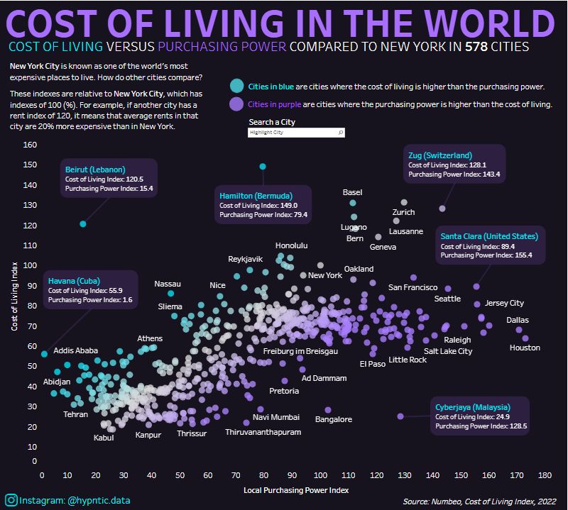

The visualization is reasonably clear, though initially overwhelming due to the abundance of data points and the use of various colors. However, the inclusion of a legend proves helpful in clarifying the meaning of the different colors and symbols.  It shows that there is a diversity of cost of living experiences around the world, even within the same region.

The visualization is somewhat complex, with a multitude of data points and an intricate color scheme, which can make it challenging to grasp upon initial inspection. The visualization remains consistent in its use of color, fonts, and line styles. However, the utilization of multiple colors and shades introduces a visual complexity. The components of the visualization lack balance, with the map dominating the majority of the space, while the legend and title appear relatively small. Color and size are use to underscore cities with a higher cost of living than purchasing power. However, it is not always straightforward to identify which cities are the most expensive or the cheapest. The visualization lacks accessibility for individuals with color blindness, as the primary method for distinguishing between cities with varying cost of living levels relies on the color scheme. Point is given where it is due though as this visualization is incredibly interactive, hover over a dot will give the user the name of the city it represent as well as it values. Furthermore, when you choose to highlight a city the entire chart dim down except for that specific city.

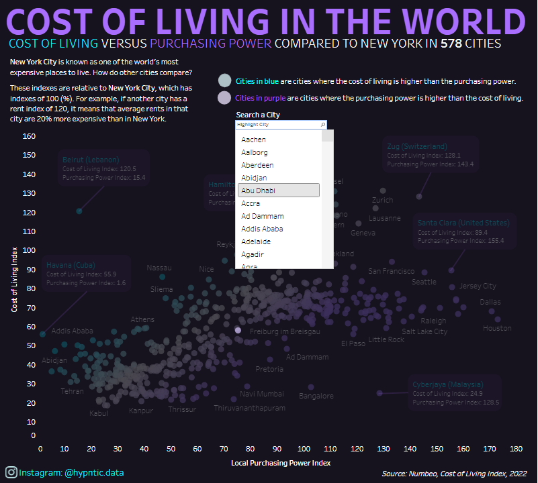

In general, the visualization is moderately effective in conveying its message and is very interactive, however, there is room for improvement by simplifying the design and employing hierarchy and emphasis more strategically. Additionally, it falls short in terms of accessibility for individuals with color blindness or visual impairments.

**3.3: Visualization 3**

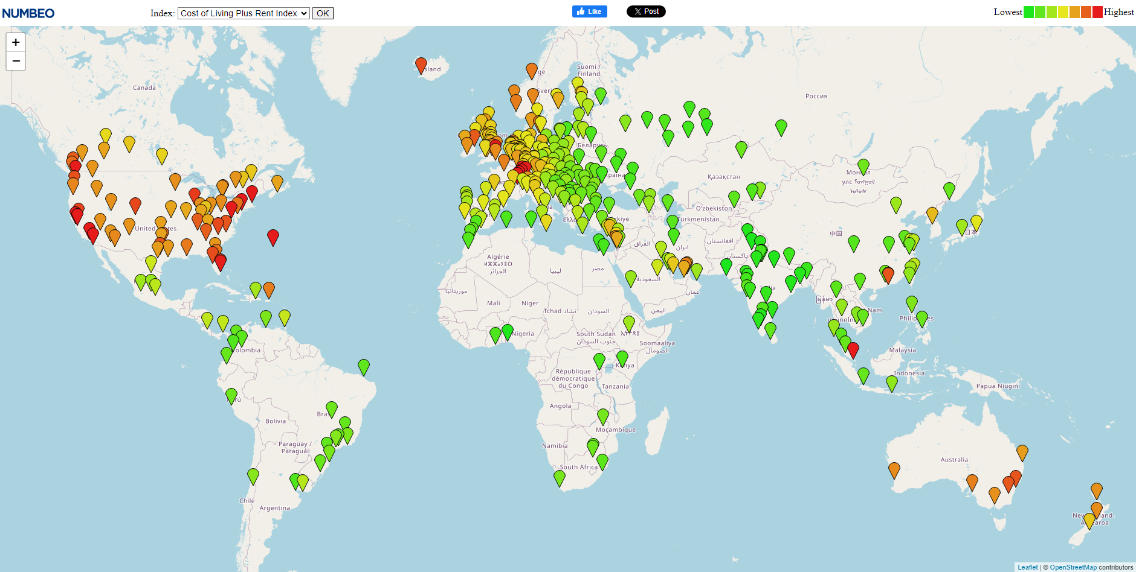

From a quick look of it,  the use of a map itself is a clear way to depict global comparisons. Different colors representing cost levels further enhance clarity.

The utilization of a map and a color gradient maintains a relatively simple visualization. Nevertheless, addressing the legibility of individual city labels and clutter arising from numerous data points could enhance the overall presentation. The color consistency is maintain with the use of a color scale that most can relate to and well understand. The color gradient effectively highlights higher cost-of-living areas but may come at the expense of visibility for lower-cost cities. Introducing supplementary visual cues for specific data points could enhance the hierarchy and overall clarity of the visualization. This map though suffer a bit from the programing side, when zoom out the map is infinitely mirror to keep it integrity.



This though can be forgiven because each interactable point on the map leads you to a very detail datasheet the explain why the point is at that color, Here are some examples:

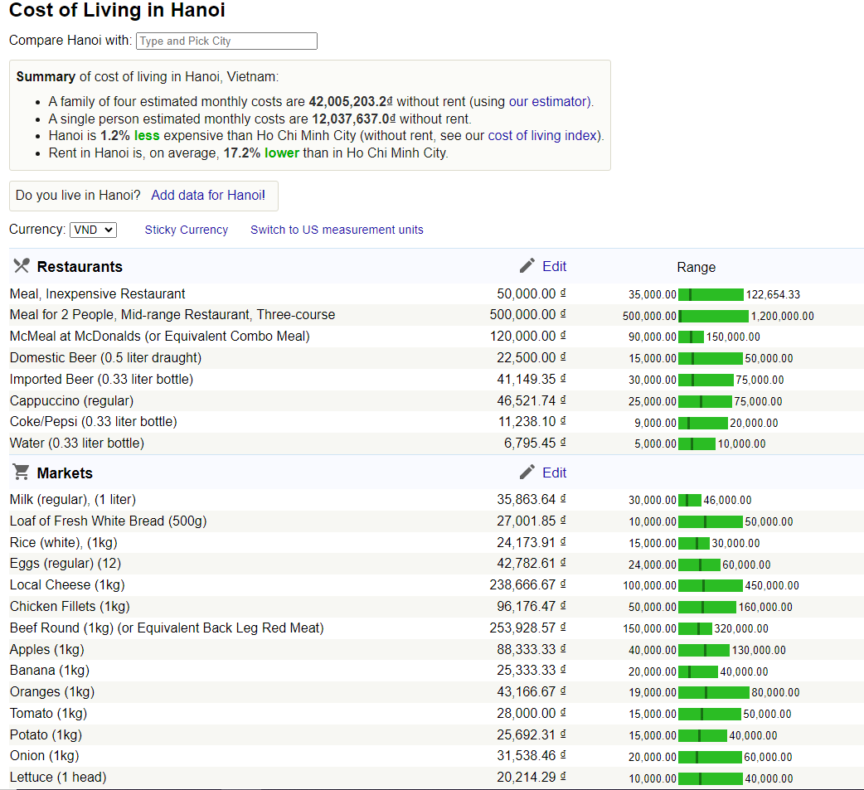

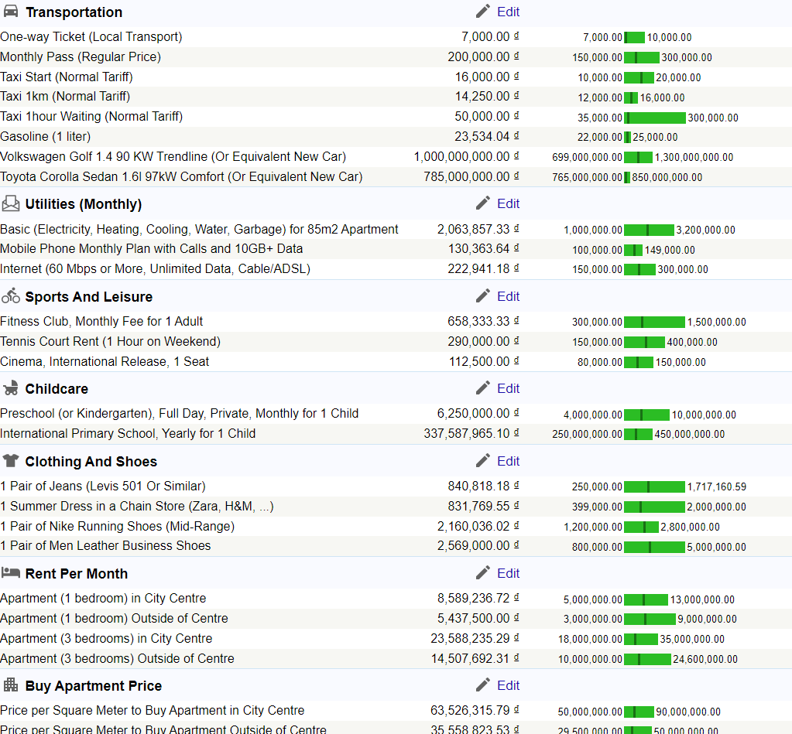

Accessibility is unsure as higher cost city is very clear but the color choices for lower cost city are very similar to each other.

In the end, The visualization appears to be reasonably effective in conveying the fundamental message of comparing the cost of living across different cities.

**CHAPTER 4**: **DISCUSSION**

To summarize, All three visualizations make use of intuitive elements such as maps and color coding, contributing to a fundamental clarity in communicating their respective messages with each visualization successfully represents the intended data by employing suitable visual elements. The first visualization appears to be well-designed overall with the second and third visualizations incorporate interactive features such as hover effects and detailed information on click, elevating user engagement and facilitating exploration.

Although interactive, the second and third visualization raise concerns regarding accessibility for color-blind viewers, as they heavily depend on color differentiation without incorporating alternative cues. Also the second and third visualization needs improvement to avoid clutter and ensure readability. While all visualizations effectively communicate their primary message, there is potential for improvement by exploring more intricate patterns or trends within the data, surpassing surface-level observations.

This assessment highlights the vital importance of incorporating inclusive design practices in visualizations, guaranteeing accessibility for a broad range of audiences, including individuals with color blindness or visual impairments. While interactive features can be beneficial, it is essential to prioritize overall clarity and prevent viewers from feeling overwhelmed by an abundance of data points or intricate interactions(Munzner, T., 2014).

**CHAPTER 5**: **CONCLUSION**

In conclusion, an examination of three cost-of-living visualizations unveiled a delicate balance between clarity and interactivity, with maps and color coding successfully conveying messages. Interactive features, such as hover effects, contributed to heightened engagement. However, concerns regarding accessibility emerged, stemming from the dependence on color differentiation in certain visualizations, and others experienced issues with crowded labels. All visualizations could derive value from uncovering more profound data patterns and trends. This review underscores the significance of prioritizing inclusive design through alternative representations, optimizing label design, and encouraging a more in-depth exploration of the data. Future work with broader access and testing can further build upon these insights, creating a more inclusive and insightful data visualization.

**REFFERENCES**

*Threat of global housing slide looms amid rising rates* (no date) *Federal Reserve Bank of Dallas*. Available at: https://www.dallasfed.org/research/economics/2023/0228 (Accessed: 18 February 2024).

Dépré, V. (2022). *Comparing the Cost of Living Around the World*. [online] Visual Capitalist. Available at: https://www.visualcapitalist.com/cp/comparing-cost-of-living-worldwide/.

Numbeo (2022). *Cost of Living*. [online] Numbeo.com. Available at: https://www.numbeo.com/cost-of-living/.

*Visualization analysis and Design* *Google Books*. Available at: https://books.google.com.vn/books?hl=en&lr=&id=NfkYCwAAQBAJ&oi=fnd&pg=PP1&dq=Visualization%2BAnalysis%2Band%2BDesign&ots=ZB-pUA7ji4&sig=6Ap0cqkUIg_xZDfw3vj1TAZyfOg&redir_esc=y#v=onepage&q=Visualization%20Analysis%20and%20Design&f=false

Ware, C. (2019). *Information Visualization: Perception for Design*. [online] *Google Books*. Morgan Kaufmann. Available at: https://books.google.com.vn/books?hl=en&lr=&id=3-HFDwAAQBAJ&oi=fnd&pg=PP1&dq=Information+Visualization:+Perception+for+Design.+Morgan+Kaufmann

Harris, R.L. (1999). *Information Graphics: A Comprehensive Illustrated Reference*. [online] *Google Books*. Oxford University Press. Available at: <https://books.google.com.vn/books/about/Information_Graphics.html?id=LT1RXREvkGIC&redir_esc=y>.

Few, S. (2012). *Show Me the Numbers: Designing Tables and Graphs to Enlighten*. [online] *Google Books*. Analytics Press. Available at: <https://www.google.com.vn/books/edition/Show_Me_the_Numbers/1xiHLgEACAAJ?hl=en>.